**Assignment 3**

**1. The process of finding the largest value (i.e., the maximum of a group of values) is used frequently in computer applications. For example, a program that determines the winner of a sales contest would input the number of units sold by each salesperson. The salesperson who sells the most units wins the contest. Build a java application that inputs a series of 10 integers and determines and prints the largest integer. Your program should use at least the following three variables:**

**a. counter: A counter to count to 10 (i.e. to keep track of how**

**many numbers have been input and to determine when all 10**

**numbers have been processed.**

**b. number: The inter most recently input by the user.**

**c. largest: The largest number found so far.**

**Note: Every time the sales figure of one employee is entered, the application should ask the user if they want to enter any more sales figures of a salesperson!**

import java.util.Scanner;

public class Main {

public static void main(String[] args) {

System.out.println("Name : Gokul Sarkar \nRoll : 46");

Scanner sc = new Scanner(System.in);

int counter = 0;

int number;

int largest = Integer.MIN_VALUE;

String answer;

while (counter < 10) {

System.out.print("Enter the sales figure: ");

number = sc.nextInt();

if (number > largest) {

largest = number;

}

System.out.print("Do you want to enter another number? (yes/no): ");

answer = sc.next();

if (answer.equals("no")) {

break;

}

counter++;

}

System.out.println("The largest 'sales figure number' is: " + largest);

}

}

**Output:**

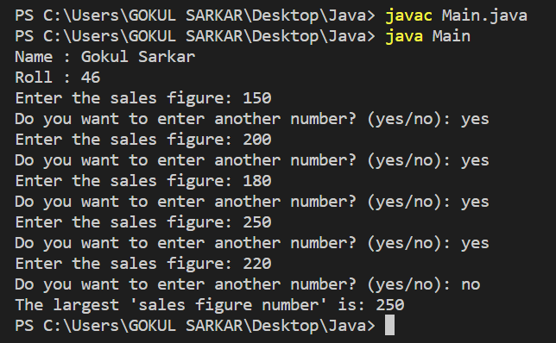

**2. Write an application that prompts the user to enter the size of the side of a square, then displays a hollow square of that size made of asterisks. Your program should work for squares of all side lengths between 1 and 20.**

import java.util.Scanner;

public class Length_of_Square {

public static void main(String[] args) {

Scanner sc = new Scanner(System.in);

System.out.println("Name : Gokul Sarkar \nRoll : 46");

System.out.print("Enter the size of the square: ");

int size = sc.nextInt();

if (size >= 1 && size <= 20) {

for (int row = 1; row <= size; row++) {

for (int col = 1; col <= size; col++) {

if (row == 1 || row == size || col == 1 || col == size) {

System.out.print("*");

} else {

System.out.print(" ");

}

}

System.out.println();

}

} else {

System.out.println("Error: Size must be between 1 and 20.");

}

}

}

**Output:**

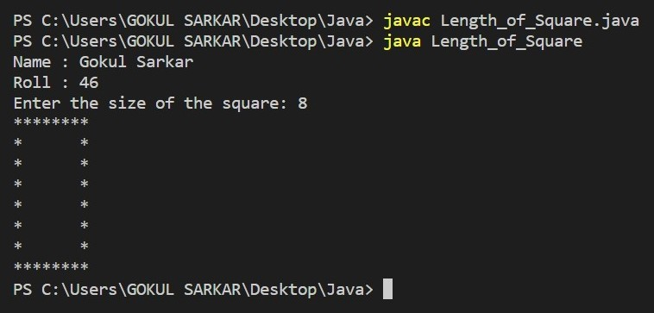

**3. Write a program to compute the following formula.**

**e= 1/0!+ 1/1! +½! + ⅓!+................+ 1/n!**

import java.math.BigDecimal;

import java.math.RoundingMode;

import java.util.Scanner;

public class Formula {

public static void main(String[] args) {

Scanner sc = new Scanner(System.in);

BigDecimal e = new BigDecimal("0.0");

BigDecimal factorial = new BigDecimal("1.0");

System.out.println("Name : Gokul Sarkar \nRoll : 46");

System.out.print("Enter the value of n: ");

int n = sc.nextInt();

for (int i = 0; i <= n; i++) {

e = e.add(BigDecimal.ONE.divide(factorial, 100, RoundingMode.HALF_UP));

factorial = factorial.multiply(BigDecimal.valueOf(i + 1));

}

System.out.println("The value of e is: " + e.toPlainString());

}

}

**Output:**

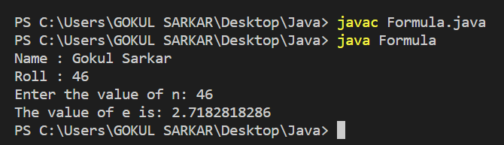

**4. Using an enhanced for (for-each) loop, copy the content of one 3-dimensional array to another 3-dimensional array and display its contents.**

public class Dimensional {

public static void main(String[] args) {

int[][][] arr1 = {{{3, 1, 2}, {5, 4, 6}}, {{9, 7, 8}, {12, 10, 11}}};

int[][][] arr2 = new int[arr1.length][arr1[0].length][arr1[0][0].length];

System.out.println("Name : Gokul Sarkar \nRoll : 46");

for (int[][] a : arr1) {

for (int[] b : a) {

for (int c : b) {

System.out.print(c + " ");

}

System.out.println();

}

System.out.println();

}

System.out.println("Copying content of arr1 to arr2...");

int i = 0;

for (int[][] a : arr1) {

int j = 0;

for (int[] b : a) {

int k = 0;

for (int c : b) {

arr2[i][j][k++] = c;

}

j++;

}

i++;

}

System.out.println("Content of arr2: ");

for (int[][] a : arr2) {

for (int[] b : a) {

for (int c : b) {

System.out.print(c + " ");

}

System.out.println();

}

System.out.println();

}

}

}

**Output:**

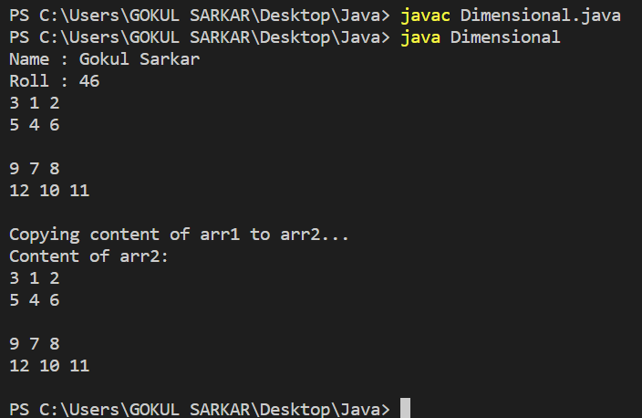

**5. Create the following vase pattern using a loop:**

**\*\*\*\*\*\*\*\*\*\*\*\***

**\                    /**

**/                    \**

**\                    /**

**/                    \**

**\                    /**

**/                    \**

**\*\*\*\*\*\*\*\*\*\*\*\***

public class Pattern {

public static void main(String args[]) {

System.out.println("Name : Gokul Sarkar \nRoll : 46");

for(int i=1;i<=7;i++) {

if(i==1 || i==7) {

System.out.println("*****************");

}

else {

System.out.println("\\ /");

System.out.println("/ \\");

}

}

}

}

**Output:**

